Sub-task 1: Replace In-Memory Storage with Azure Database for PostgreSQL
- Screenshots displaying the configuration of the Azure Database for PostgreSQL.
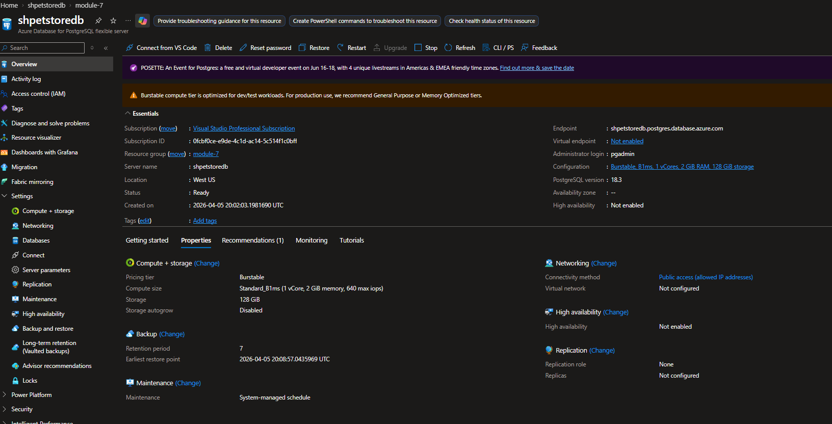
- Screenshots showcasing the modified code in the Pet and Product Services, illustrating the integration of PostgreSQL as the new storage system.
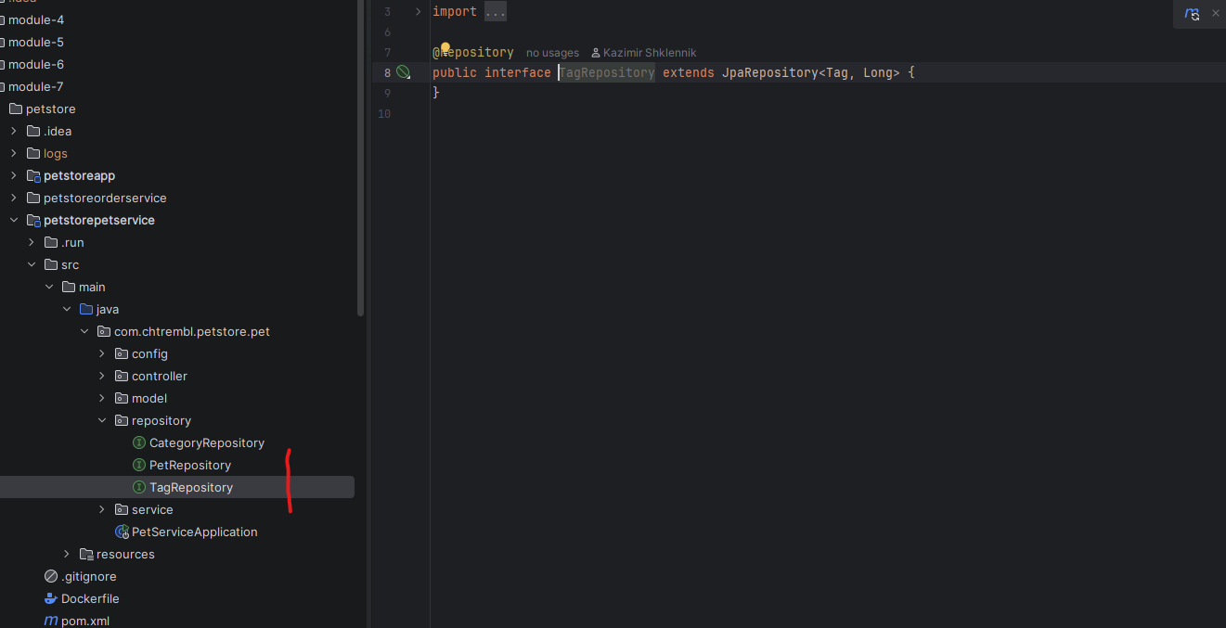
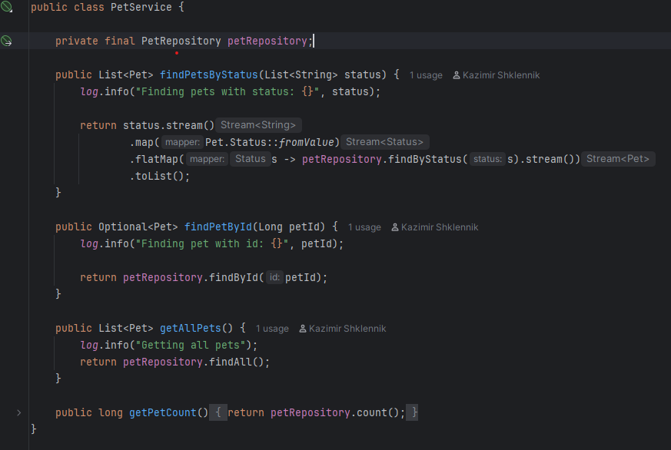
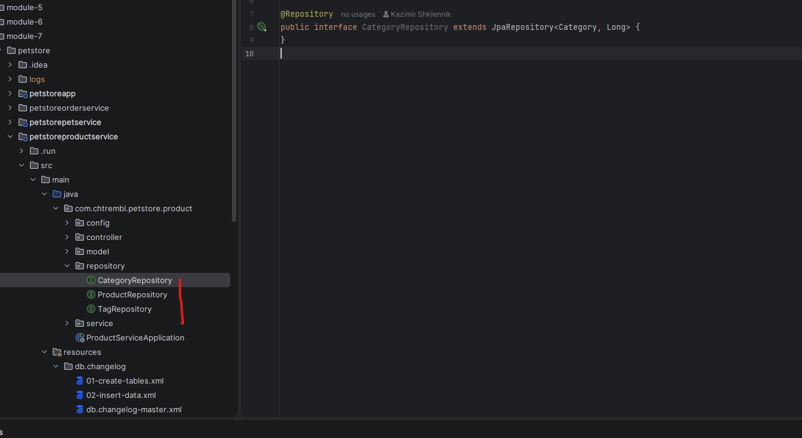
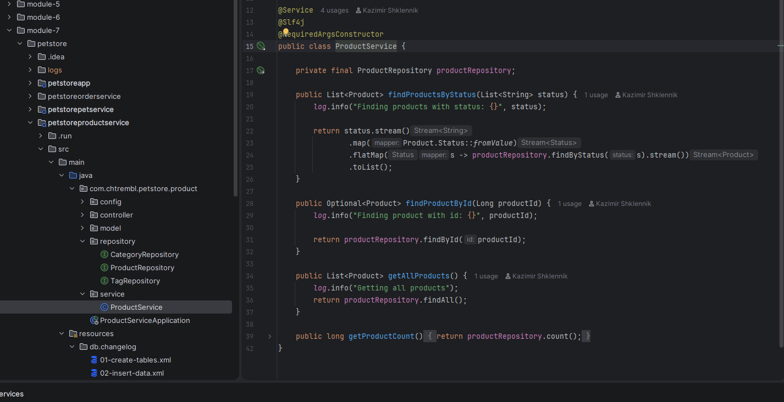
- Screenshots of the PostgreSQL database schema, showing the created tables and their structure.
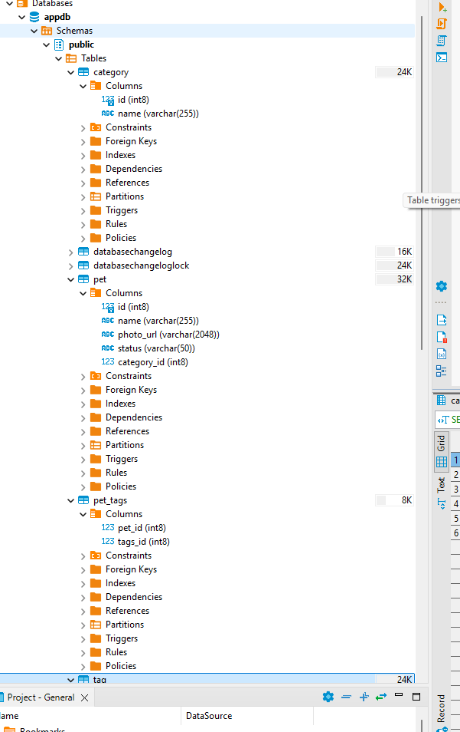
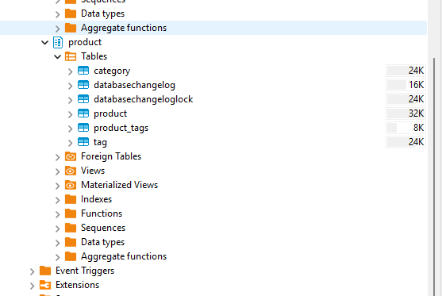
Sub-task 2: Implement Order Storage using CosmosDB
- Screenshots showing the configuration of CosmosDB.
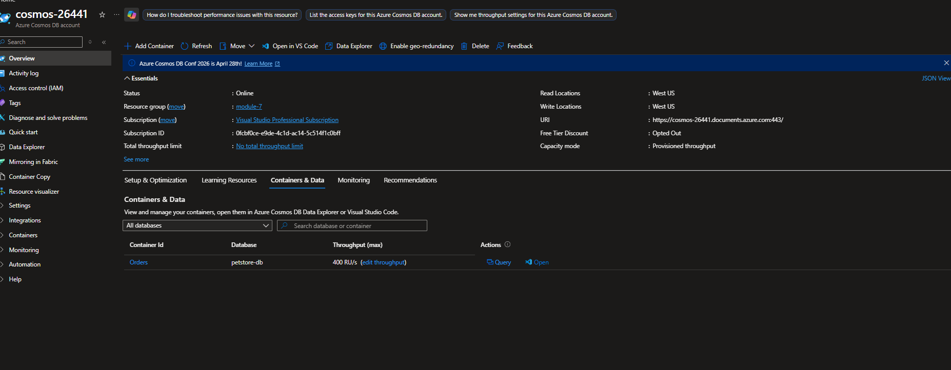
- Screenshots demonstrating the modified code in the Order Service, highlighting the integration of CosmosDB as the new storage system for orders.
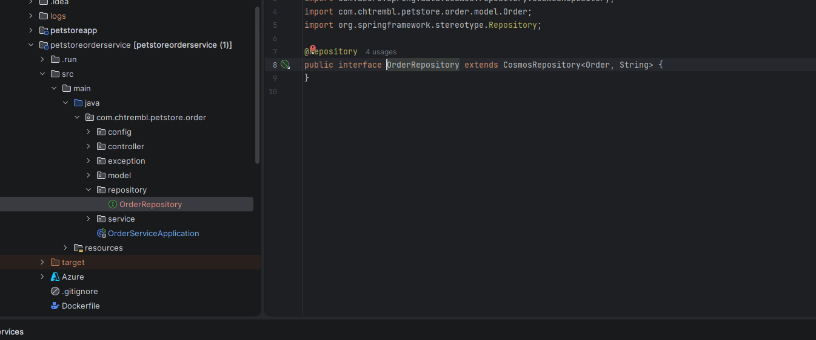
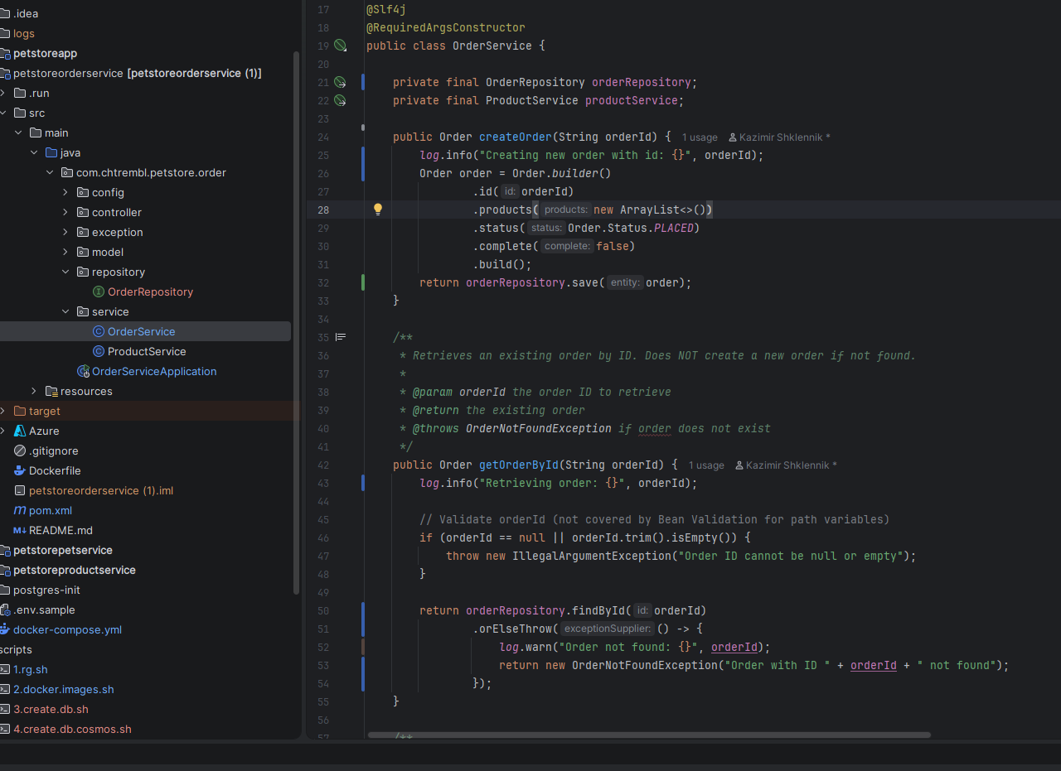
- Screenshots illustrating the application's functionality for placing an order.
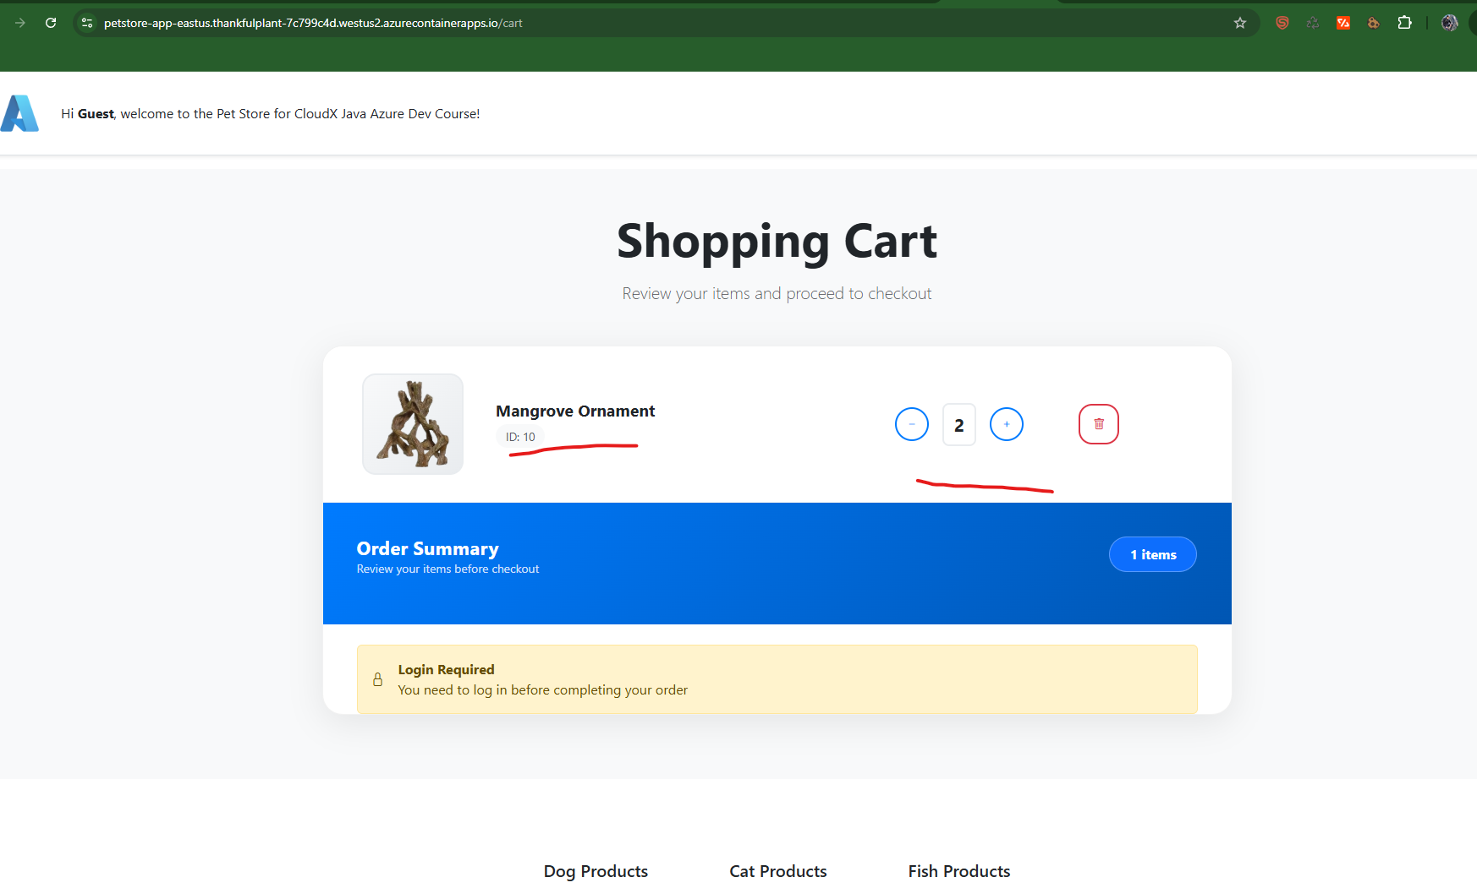

- Screenshots of the CosmosDB Data Explorer, displaying the newly created record in Order Storage.
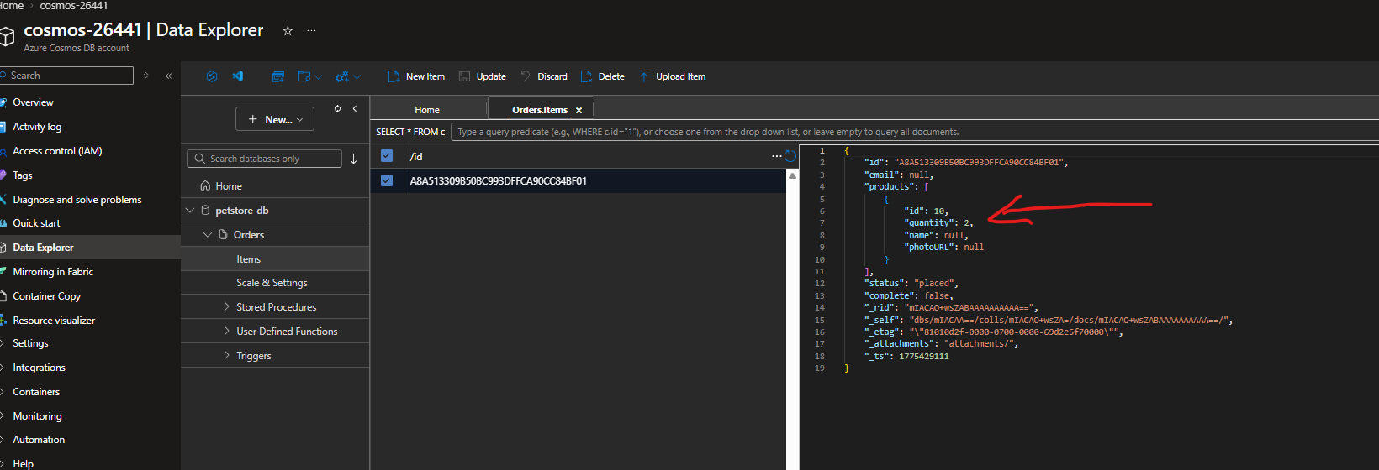
- A screenshot showing the list of Azure resources that correspond to the diagram.
